**Gantt chart**

**Network diagram**

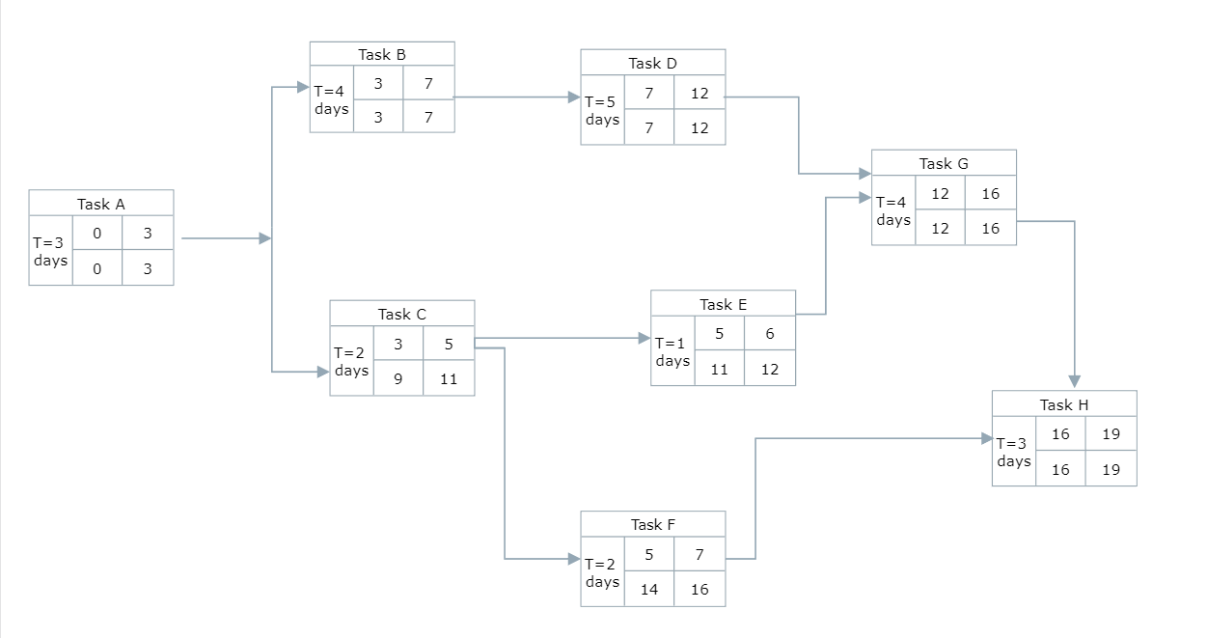

When is the delivery date?

* Early Finish :16 Unit time
* Late Finish :19 Unit time

Which tasks could be delayed without delaying the schedule?

* Task E, F can be delayed without delaying the project